Utility Hub
Essential tools for everyday tasks – All in one place.
Welcome to Utility Hub, your one-stop destination for performing common digital tasks with ease. Whether you're a developer, student, or just someone who needs quick access to simple utilities, we've got you covered!
🚀 Features:
- 🔢 Calculator – Perform quick calculations without switching tabs.
- ⚖️ BMI Calculator – Instantly check your Body Mass Index.
- 🔐 Password Generator – Create strong, secure passwords in one click.
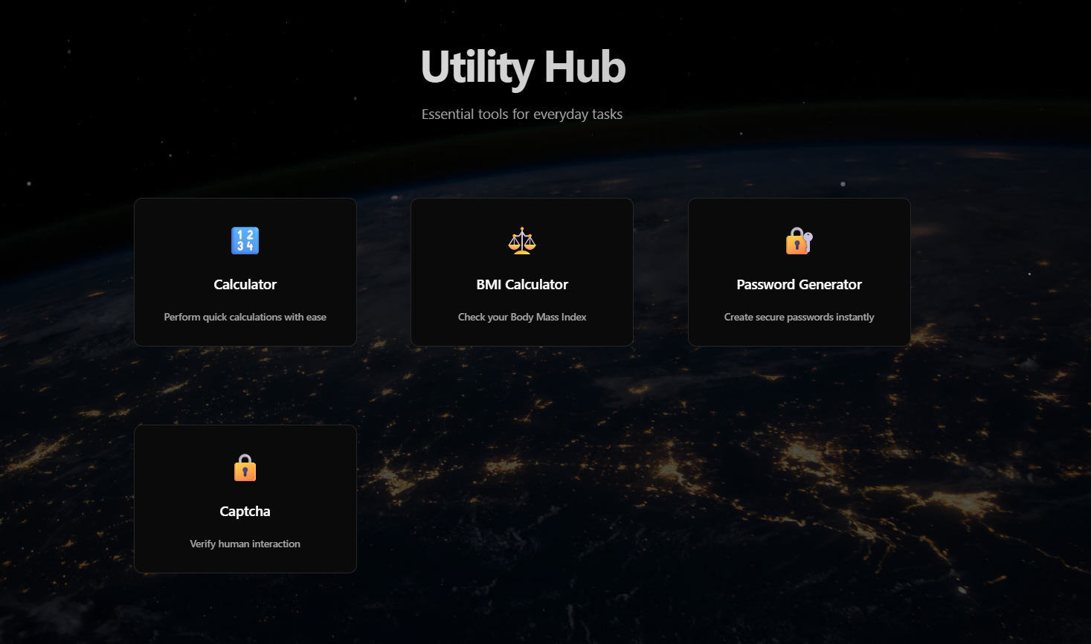
- 🔎 Captcha – Test and verify human interaction for forms or demos.

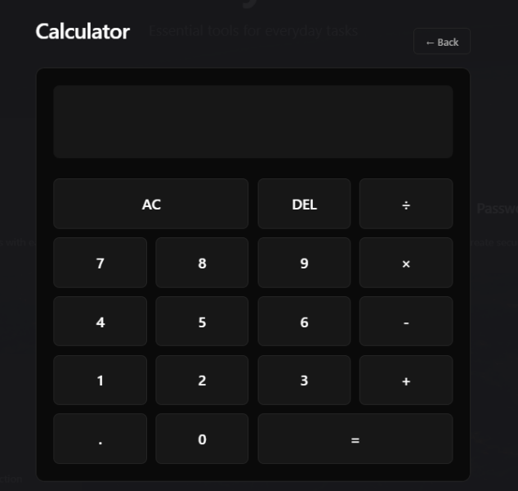
This is a simple calculator web interface from your "Utility Hub" project. Here's a breakdown of how it works and what each element means:

🧮 UI Explanation:
🔳 Top Display Box
- The large black box at the top is the output/display screen where the numbers and results appear as the user types or performs calculations.
- 🟦 Buttons Functionality:
Button |  |  | Function
AC |  |  | All Clear – Clears the entire input or current expression.
DEL |  |  | Delete – Removes the last digit or character entered.
÷ × - + |  |  | Operators – Used for division, multiplication, subtraction, and addition respectively.
. |  |  | Decimal Point – For floating point numbers.
0–9 |  |  | Digits – Number buttons for numeric input.
= |  |  | Equals – Evaluates the current expression and shows the result.
← Back |  |  | Navigates back to the main Utility Hub page.

🌐 Technology Likely Used:
This calculator is likely made using:
- HTML for structure
- CSS for layout and dark theme styling
- JavaScript for the actual calculator logic and interactivity

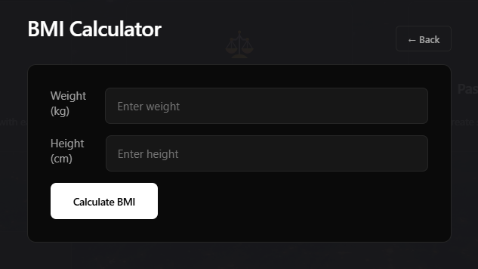
This image shows the BMI Calculator tool section from your Utility Hub project. Here's a detailed explanation of its functionality and layout:

⚖️ BMI Calculator – Breakdown
📌 Purpose:
This tool allows users to calculate their Body Mass Index (BMI), a measure used to determine whether a person has a healthy weight for their height.

🖥️ UI Elements:
Component | Description
Weight (kg) Input Box | User enters their body weight in kilograms.
Height (cm) Input Box | User enters their height in centimeters.
"Calculate BMI" Button | When clicked, it triggers the calculation and displays the BMI result.
← Back Button | Navigates back to the main Utility Hub interface.

📐 BMI Formula Used:
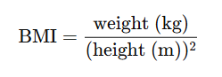
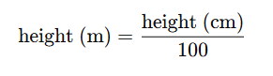

✅ Output (Usually Displays):
- BMI Value
- Optional interpretation (underweight, normal, overweight, obese)

🛠️ Technologies Likely Used:
- HTML/CSS for form structure and styling
- JavaScript for logic to:
  - Read input values
  - Perform calculation
  - Show the result dynamically
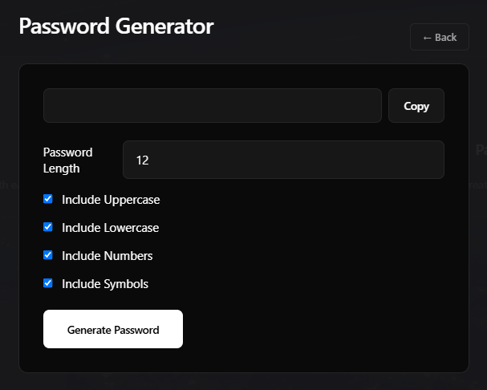

This image shows the Password Generator page from your Utility Hub project. Here's a full explanation:

🔐 Password Generator – Overview
📌 Purpose:
This tool is used to generate strong, random passwords based on user-selected criteria. It helps users create secure credentials that are harder to guess or brute-force.

🖥️ UI Elements Breakdown:
Element | Function
Password Display Box | Displays the generated password.
Copy Button | Copies the generated password to clipboard.
Password Length Input | Allows the user to specify the desired password length (e.g., 12 characters).
- Include Uppercase | Toggle to include uppercase letters (A-Z) in the password.
- Include Lowercase | Toggle to include lowercase letters (a-z) in the password.
- Include Numbers | Toggle to include numbers (0-9) in the password.
- Include Symbols | Toggle to include special characters (e.g., !@#$%^&*) in the password.
Generate Password Button | Generates a password using selected options and displays it.
← Back Button | Returns the user to the main homepage (Utility Hub).

⚙️ How It Works (Logic Overview):
- User sets password length.
- Selects desired character sets:
  - Uppercase: A–Z
  - Lowercase: a–z
  - Numbers: 0–9
  - Symbols: !@#$%^&*()_+-=[]{};:'",.<>?/
- Click on "Generate Password".
- JavaScript generates a random password using the selected criteria.
- User can copy the password using the "Copy" button.

🛠️ Likely Tech Stack:
- HTML/CSS for layout and styling
- JavaScript for:
  - Generating random characters
  - Handling toggles and input
  - Clipboard copy function
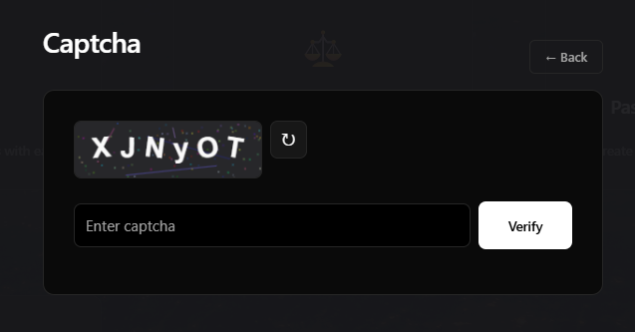

This is the Captcha page from your Utility Hub project. Here's an explanation of each part:

🧠 Captcha – Human Verification Tool
📌 Purpose:
The Captcha tool verifies that the user is human, not a bot. It helps prevent automated abuse (like spam or brute-force attacks) by requiring human interaction.

🖥️ UI Elements Breakdown:
Element | Function
Captcha Image | Shows a randomly generated alphanumeric string (e.g., XJNyOT) with visual noise to prevent automated recognition.
Reload/Refresh Button 🔁 | Generates a new captcha code image (if the current one is hard to read).
Text Input Field | The user must type the captcha code shown in the image here.
Verify Button | Submits the entered text for validation against the actual captcha value.
← Back Button | Returns to the main Utility Hub page.

⚙️ How It Works (Backend Logic Overview):
- When the page loads or the refresh button is clicked:
  - A new random string (e.g., 6 characters) is generated.
  - The string is rendered as an image with distortion, lines, or dots to make it hard for bots to interpret.
- User types what they see.
- On clicking Verify:
  - JavaScript or backend compares the input with the generated code.
  - If they match → ✅ Success message.
  - If they don't → ❌ Error message.

🛠️ Likely Tech Stack:
- Canvas API in JavaScript or an image-generating library (e.g., Python’s captcha or PHP’s GD library) to create the captcha image.
- Frontend validation using JavaScript.
- Backend (optional) for server-side validation.

